
Toys

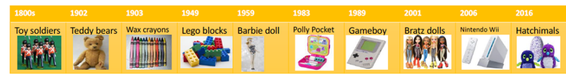

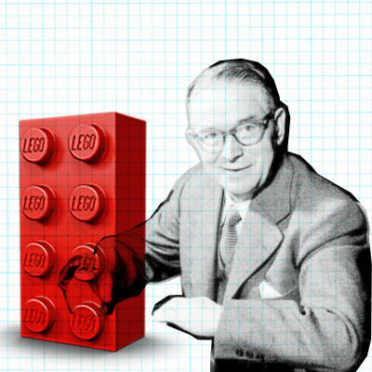
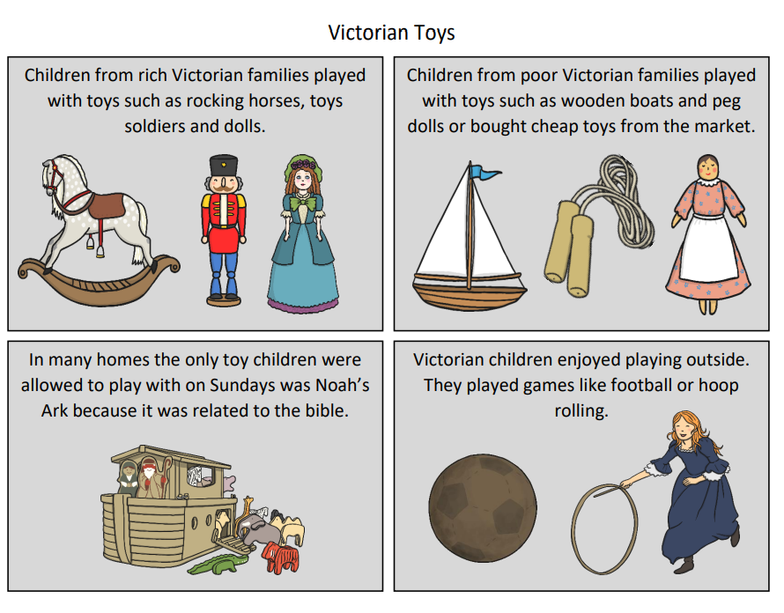
Key vocabulary
dolls
meccano
teddy bears
board Games
doll House
ball and cup
building blocks
computer games
toys
favourite
today
Victorian
then/ past
now/ present
before
after
evidence
sources
compare
century
chronology

Ole Kirk Christiansen
He called his toy company Lego in 1939. The plastic blocks were made in 1949 and are still hugely popular today.

Richard Steiff
In Germany, Richard Steiff based
one of his toy designs on a bear he saw
at the zoo. In 1902 the Steiff company started making teddy bears.

Significant People

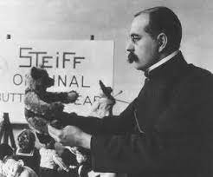

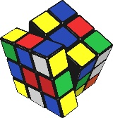
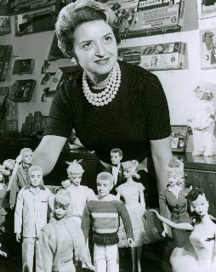

Did you know?
The top five highest selling toys ever are:
- Hot Wheels
2. Rubik’s Cube
3. Cabbage Patch Dolls
4. Barbie
5. LEGO
Ruth Handler
She invented the Barbie Doll in 1959. She named the doll after her daughter Barbara.

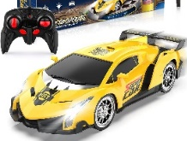
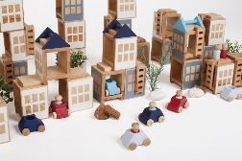
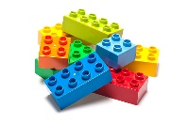

General Knowledge

-Toys were made from any material that was available. Even stones and string have been made into toys.

-Toy were mainly made of wood, paper or metal during the Victorian age.

-Modern toys are mainly made of plastic, although wooden toys are still popular.

-Many modern toys use electricity to work.
Key vocabulary

materials
wood
plastic
metal
glass
paper
fabric
bend
stretch
twist
rough
smooth
soft
hard
strong
tough

Toys

