Carnival of the Animals - Geography

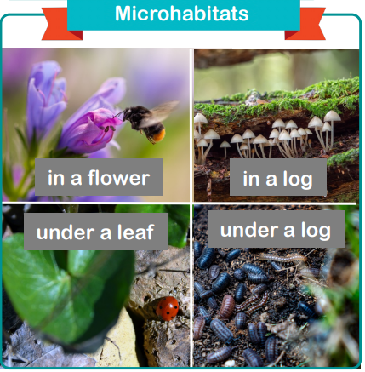
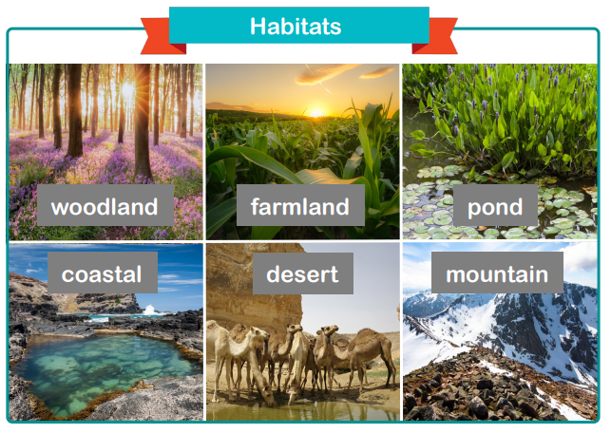
Vocabulary:
Asia, Africa, North America, South American, Europe, Antarctica, Australia

Pacific, Atlantic, Southern, Indian, Artic

Woodland, farmland, pond, coastal, desert, mountain, rainforest, Arctic, ocean, habitat, environment, endangered, climate, adapt, globe, atlas, map.

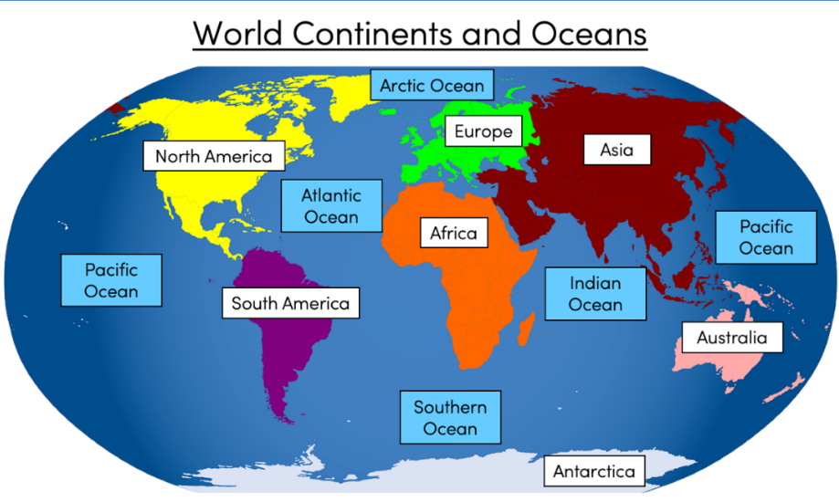
Did you know?

A habitat is the home of an animal or a plant.

The Earth is always changing which mean habitats are constantly changing.

All habitats must have food, water, air, space and shelter.

Carnival of the Animals –
Living things and their habitats

Vocabulary:

Living, non-living, dead, herbivore, carnivore, omnivore, consumer, producer, predator, prey, amphibians, birds, fish, mammals, reptiles, identify, sort, group, food chain, survive, obtain

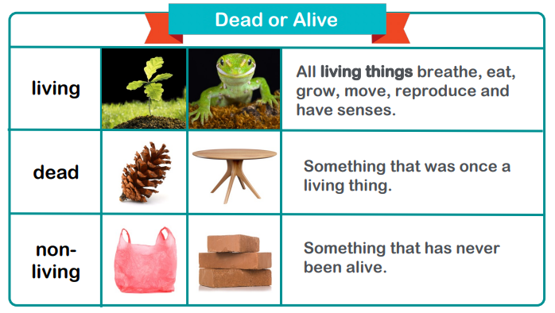
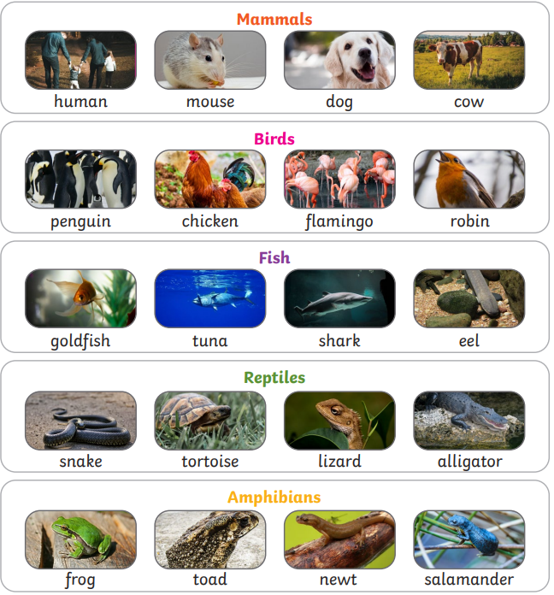

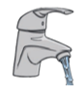

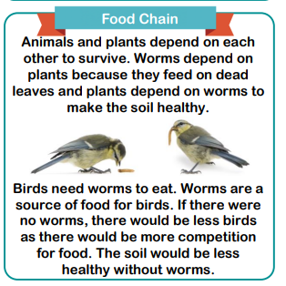
Did you know?
To stay alive, an animal needs 3 things.

Air Food

Water

Food

