Topic:  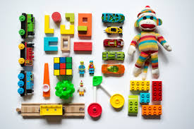  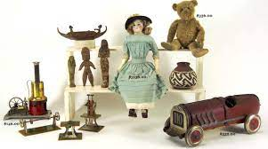  Toys and books | Overview:  Our expedition of toys and books will give the children a breadth of knowledge about toys past and present. We will take a historical approach to our learning through the discovery and exploration of toys our parents and grandparents played with, comparing them to the toys we play with. We will also learn about toys during the Victorian era. The children will learn about how toys and books have developed over time and make links to the introduction of technology and its advances over the years. The children will also investigate what materials toys are made from and form their ideas through observation and investigations as to what the best material for toys are. In addition, we will also be learning about significant toys from around the world and making comparisons to what we have in this country. | 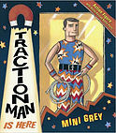  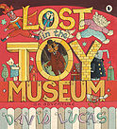  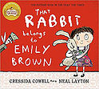  Books:  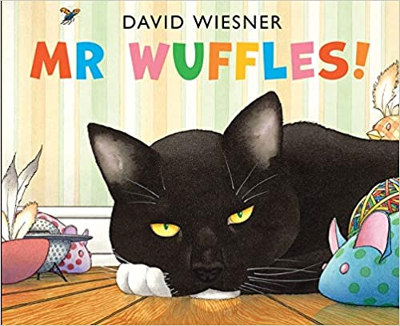  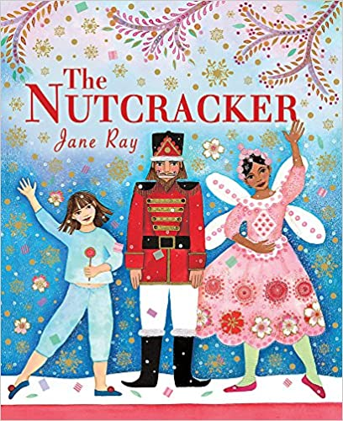  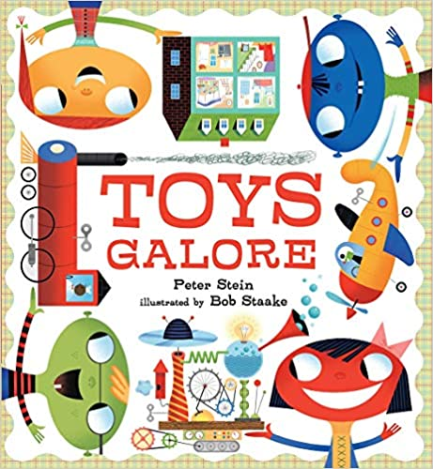  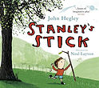  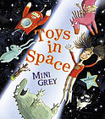  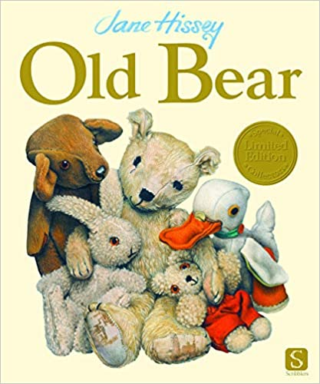  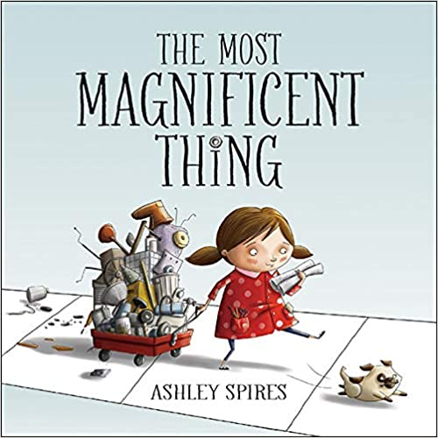  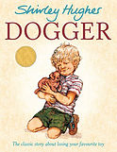  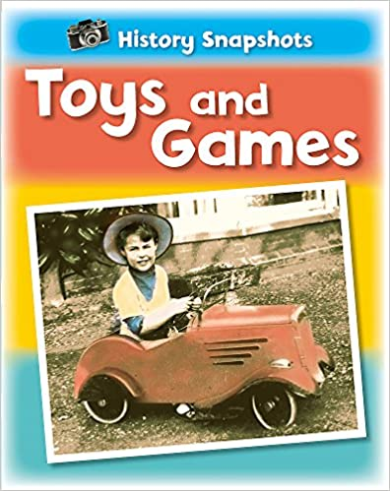  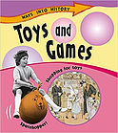  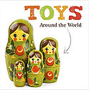  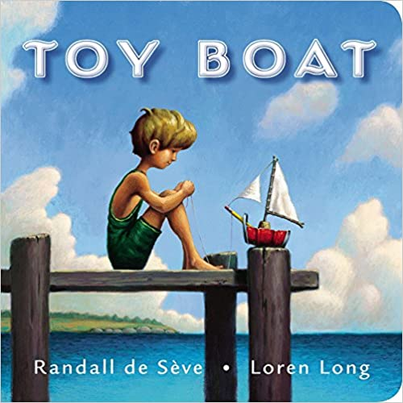
Knowledge:
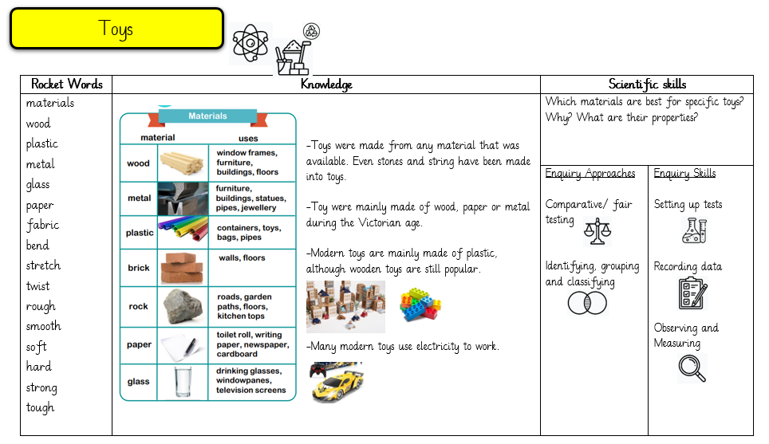
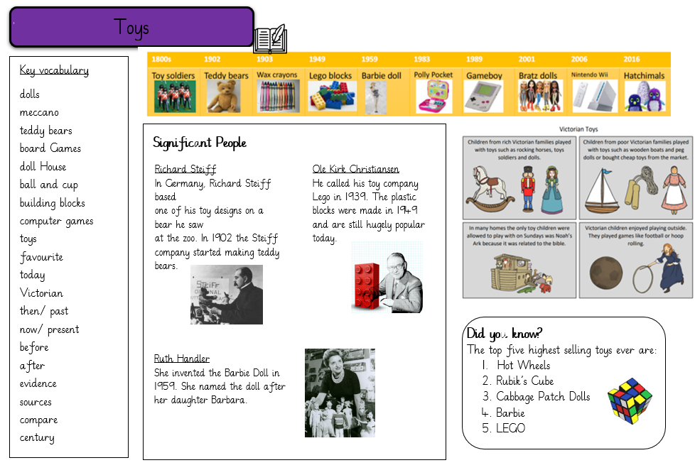
Science:

Our primary focus is the use of materials for toys. We will then explore in depth the seasonal changes of winter.

Week 1: What materials are toys made from? Why are they made from these materials? What are their properties?
Vocabulary:
Wood, rock, metal, glass, plastic, cardboard, brick, paper, transparent, opaque, materials, stiff, soft, shiny, rough, bendy, stretchy, absorbent, water, smooth, waterproof, dull, hard.
Week 2: How can we explore and test the stretchiness of materials?
Week 3: How can materials change their shape?
Week 4: Which materials are best for specific toys?
Week 5: What are the four seasons?
Week 6: What changes take place in Winter?
Week 7: Review week

History and Geography:
Vocabulary:
Map, atlas, country, continent, hemisphere, global

Toys, favourite, today, Victorian, then, now, before, after, evidence, sources, past, present, old, older, oldest, question, new, newer, newest, compare, century

Week 1: What toys do we play with? What toys did our parents and grandparents play with?
Week 2: What toys were played with during Victorian compares? How are they the same and different to modern day?
Week 3: Who invented the teddy bear?
Week 4: What toys are popular? What makes a popular toy?
Week 5: What toys are popular around the world? Where do toys come from?
Week 6: How have books changed over time?
Week 7: What might toys and books look like in the future?
English:

We will be exploring and writing postcards and character descriptions using the series of books ‘Traction Man’ by Mini Grey for our inspiration.
Art/ DT:

We will be:
- Making observational drawings of teddy bears using the text, ‘Old Bear’ by Jane Hissey for inspiration.
- Researching, making and evaluating 5 string puppets.
- We will be making stick puppets to retell the Christmas story.
RE:

Why does Christmas matter to Christians?

We will explore the meaning of Christmas through the nativity story, the Christian traditions of Christmas and the importance this festival holds.

