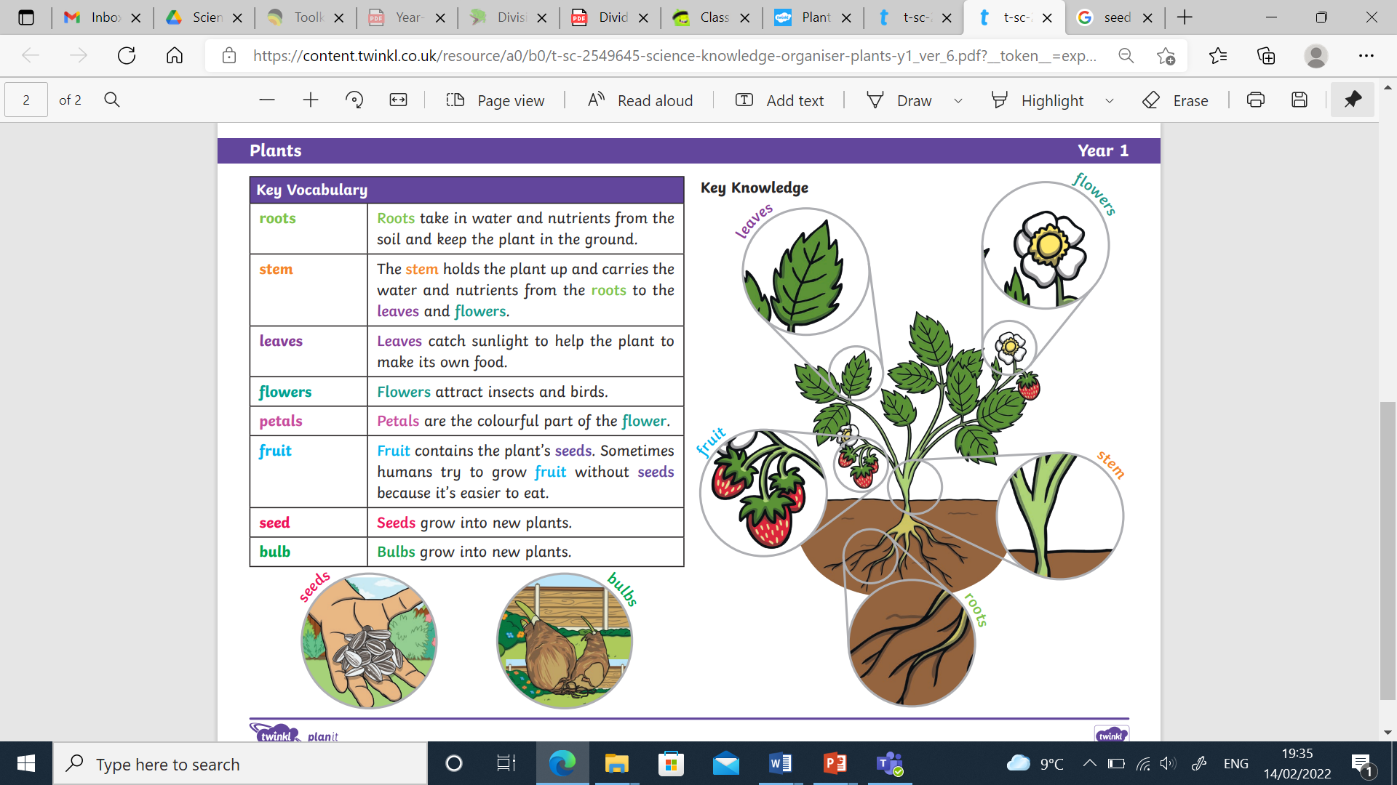

**Key Vocabulary**

grow

seeds

bulbs

roots

stem

leaves

flowers

petals

fruit

trunk

tree

garden plant

wild plant

weed

deciduous tree

evergreen tree

dandelion

daisy

rose

pansy

sunflower

maple

oak

Plants

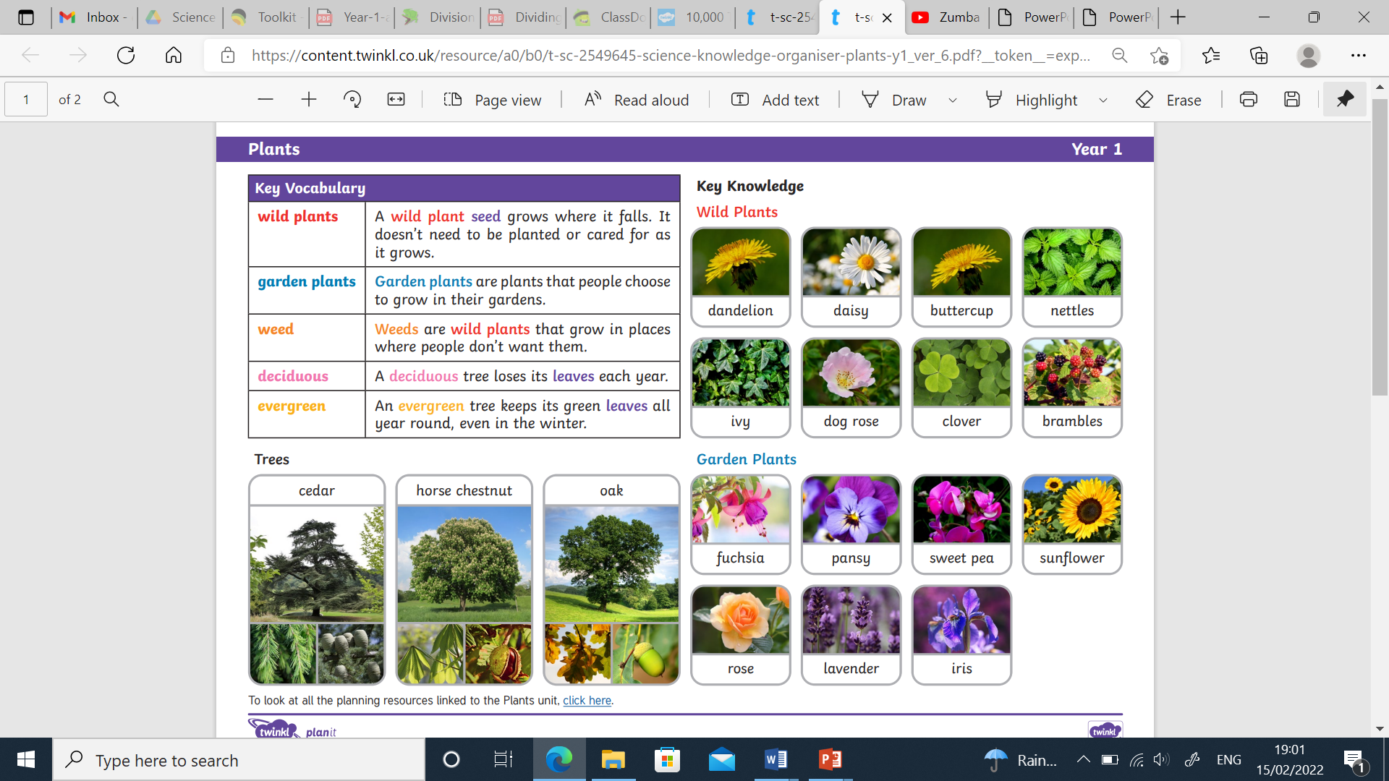

A wild plant will grow by itself. It does not need to be cared for.

A flower grown especially in a garden. It will need to be cared for.

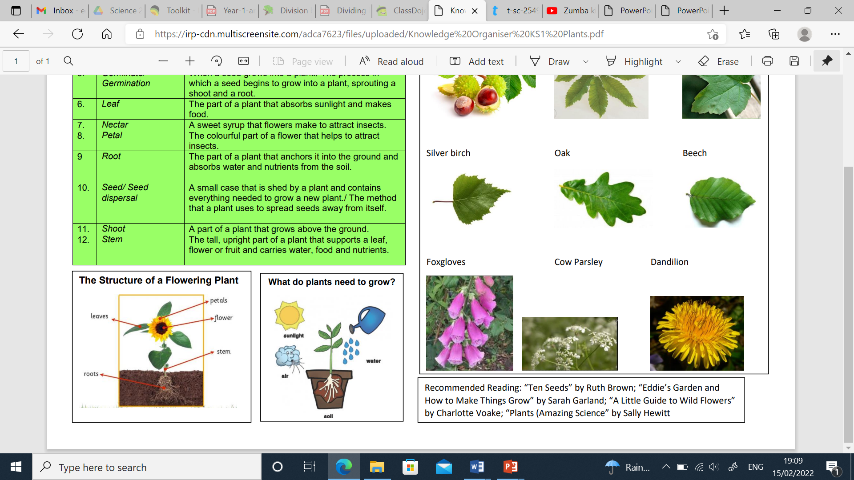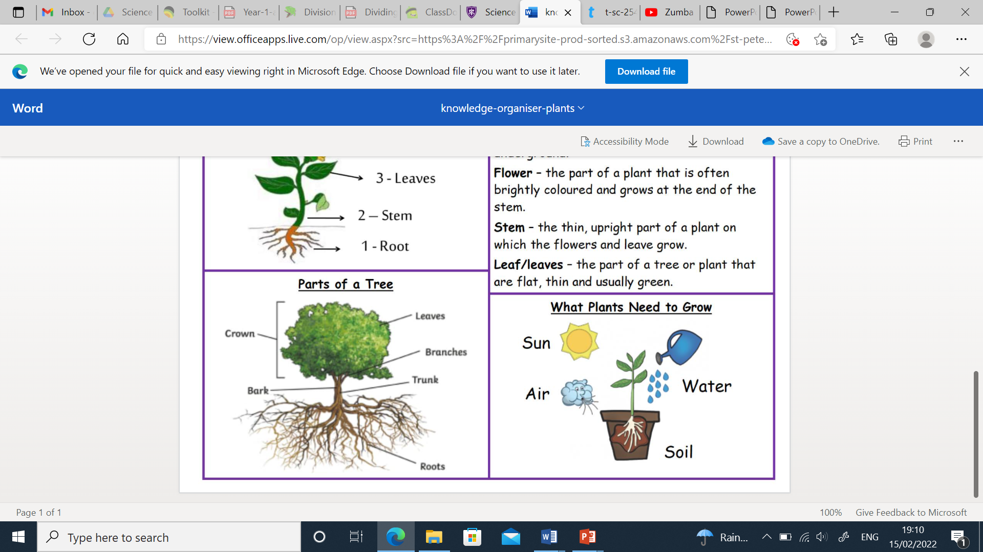

Did you know?

A deciduous tree loses its leaves each year.

An evergreen tree keeps its green leaves all year round, even in winter.