Healthy and Happy –
History

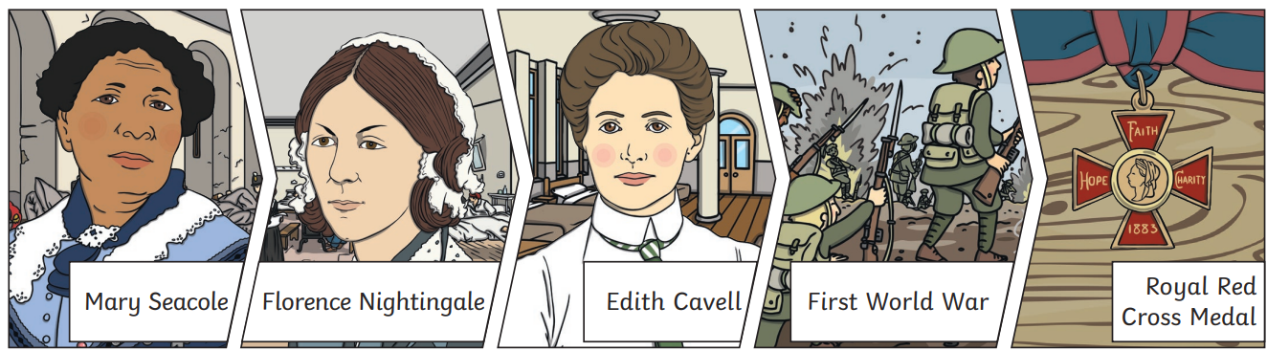

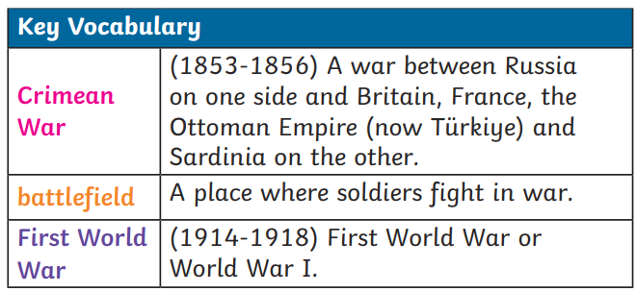
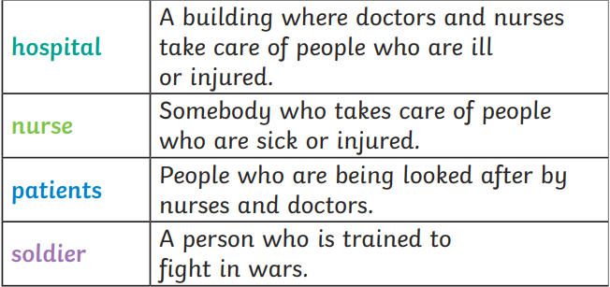
Edith Cavell
1865-1915

Edith Cavell was a nurse in the First World War. She saved soldiers from both sides during the First World War. Edith helped over 200 soldiers escape from the German army.
Florence Nightingale
1820-1910

Florence Nightingale was a nurse. She made hospitals cleaner for patients and looked after soldiers in the Crimean War. She set up the Nightingale Training School for nurses in 1860
Mary Seacole
1805-1881

Mary Seacole was a nurse. Her mother was Jamaican and her father was Scottish. She travelled from Jamaica to look after wounded soldiers on the battlefield in the Crimean War. She set up a hospital called the British Hotel to look after soldiers.

