Mawnan CE VA Primary School

Relationships and Health Education Policy
Review Cycle | Date of Current Policy | Author(s) of Current Policy | Review Date
1 Year | March 2022 | J Pridmore & P Blight | March 2023

Review & Ratification Required by Governor’s Sub-Committee Only | Name of Governor’s Sub-Committee | Ratification required by Full Governing Board
Yes | Curriculum and Standards Committee | Yes

Reviewed by Governor’s sub-committee
Role | Name | Signature | Date

Ratified by the Full Governing Board
Role | Name | Signature | Date

Details of Policy Updates
Date | Details
January 2022 | Changed Appendix 2 – Updated PSHE Curriculum. Now in roadmaps.  Biblical passages added to reflect our school values and Christian distinctiveness.  Changed Appendix – Updated sample letter to parents  Sex Education – Updated how Sex Education is delivered.
- Rationale
We distinguish Relationships and Health Education as learning about caring friendships, families and people who care for me, respectful relationships, online relationships, being safe, growing up and puberty. Sex Education is also covered in Relationships Education as well as aspects of sex education being covered in the National curriculum: Science programmes of study (see appendix 1). Sex education is defined in this policy as, preparing boys and girls for the changes that adolescence brings and the scientific process of how a baby is conceived and born.

Our approach to Relationship, Sex and Health Education (RSHE) seeks to be faith-sensitive and inclusive. It is underpinned by two key Biblical passages:
“So God created humankind in his image, in the image of God he created them”
(Genesis 2:7)
“I have come in order that you might have life - life in all its fullness”
(John 10:10)
Relationships and Health Education provides an excellent forum to provide pupils with life-skills that will enable them to make informed decisions and protect themselves against harmful and exploitative situations. Relationships and Health Education is therefore a tool to safeguard children. Relationships and Health Education contributes to the foundation of PSHE and Spiritual, Moral, Social and Cultural (SMSC) development and offers a valuable vehicle for promoting equality between individuals and groups. It involves an exploration of human and social diversity, and a fostering of self-worth whilst recognising, accepting and respecting differences.

Aspects of Relationships and Health Education are taught as an integral part of the school’s PSHE provision throughout the primary school from Reception to Year 6. This way the children are able to develop their ideas, knowledge and skills gradually and appropriately in a non-threatening environment.

Relationships Education and Ofsted

The 2019 Ofsted framework states that pupils should be able to recognise online and offline risks to their well-being – for example, risks from criminal and sexual exploitation, domestic abuse, female genital mutilation, forced marriage, substance misuse, gang activity, radicalisation and extremism – and making them aware of the support available to them. It also states that schools should ensure they are developing pupils’ age-appropriate understanding of healthy relationships through appropriate relationship and sex education.

The 2019 Ofsted framework also states:

From September 2019, schools are able to follow a new relationships and sex education and health education curriculum. From September 2020, they will be required by law to follow it. Primary-age children must be taught about positive relationships and respect for others, and how these are linked to promoting good mental health and well-being. In addition, sex education will become mandatory at secondary level. If a school is failing to meet its obligations, inspectors will consider this when reaching the personal development judgement.
Relationships and health education in primary schools became compulsory in September 2020 as planned; however, due to the impact of the coronavirus (COVID-19) pandemic, schools have been offered flexibility on when to begin delivering these subjects within the 2020/2021 academic year.
Schools that are prepared to deliver teaching in these subjects and have assessed that they meet the requirements in the DfE’s ‘Relationships education, relationships and sex education (RSE) and health education’ guidance are encouraged to begin delivering teaching as soon as practically possible, and no later than the start of the Summer term in 2021.. In these cases, a phased approach should be used (if needed) when introducing the subjects.

Moral and Values Framework

The Relationships and Health Education Policy will be sensitive towards the established morals and values framework of all the major world religions and philosophies. The Relationships and Health Education Policy will complement the Religious Education Policy of our school and the RE scheme of work. All of our policies and schemes of work uphold the British Values of tolerance and respect.

2. Statutory requirements

Schools are required to comply with relevant requirements of the Equality Act 2010. Further guidance is available for schools in The Equality Act 2010 and school’s advice. The DfE guidance states that schools should pay particular attention to the Public sector equality duty (PSED).

Under the provisions of the Equality Act, schools must not unlawfully discriminate against pupils because of their age, sex, race, disability, religion or belief, gender reassignment, pregnancy or maternity, marriage or civil partnership, or sexual orientation (collectively known as the protected characteristics). Schools must also make reasonable adjustments to alleviate disadvantage and be mindful of the SEND Code of Practice when planning for these subjects.

As a maintained primary school, we must provide Relationships and Health Education to all pupils as per section 34 of the Children and Social work act 2017. We are not required to provide sex education, but we do need to teach the elements of sex education contained in the National curriculum: Science programmes of study. Our school also delivers sex education as part of Relationships and Health Education. Parents can withdraw their child from sex education lessons of the Relationships Education curriculum (see section 8).

In teaching Relationships and Health Education, we must have regard to guidance issued by the secretary of state as outlined in section 403 of the Education Act 1996. At Mawnan Primary School we teach Relationships Education as set out in this policy.

3. Policy development

This policy has been developed in consultation with governors, staff, pupils and parents.
The Department for Education and Ofsted have clearly outlined aspects of Relationships and Health Education that are statutory in all primary schools, therefore some recommendations or comments made during the consultation process may not be reflected in the final policy as our school has to ensure we are meeting statutory guidelines. The steps taken to review the policy are as follows.

- Review – members of the Relationships and Health Education working party looked through the existing Relationships Education policy as well as local and national guidance for Relationships and Health Education. The working party will then review the Relationships and Health Education policy reflecting any advice and changes at local and national level.
- Staff consultation – Staff are also consulted via a staff meeting. All staff have been sent the draft policy and are invited to comment on the policy and make suggestions/amendments.
- Parent consultation- Parents are consulted via an online Google form. Parents will be given the opportunity to look through the draft policy and offer comments/suggestions.
- Pupil consultation – Pupils are consulted via pupil conferencing in school. Pupils will be given the opportunity to look through this policy, specifically Appendix 2, and talk about Relationship and Health Education lessons.
- Governor consultation - Governors were consulted on this policy via a governor meeting. All governors were sent the draft policy in advance of the meeting and were then invited to comment on the policy and make suggestions/amendments.
- Ratification – once amendments are made, the policy will be shared with governors and ratified. The policy will then be ratified by the governing body in March 2022.

This policy will be reviewed every year. This policy will next be reviewed in March 2023.

4. Aim and outcomes

The aim of this policy is to enable the effective planning, delivery and assessment of Relationships and Health Education.

The aims of Relationships and Health Education at our school is to:

- Develop confidence in talking, listening and thinking about feelings and relationships;
- Teach pupils the correct vocabulary to describe themselves and their bodies;
- Be prepared for puberty and understand the basic changes that happen during puberty;
- Understand how to keep their bodies healthy and clean;
- Understand how to keep themselves and their bodies safe;
- Help pupils develop feelings of self-respect, resilience, confidence and empathy;
- Help pupils recognise healthy friendships;
- Provide a safe environment in which sensitive discussions can take place;
- Foster respect for the views of other people;
- Develop skills to negotiate life’s challenges, opportunities, and risks.

The outcomes of Relationships and Health Education at our school is to:

- Ensure our children are safe, happy and resilient learners who endeavour to show kindness, trust and compassion to others and themselves.
- Ensure the knowledge, skills and attributes taught within our curriculum have a positive impact in improving emotional wellbeing, academic attainment and preparation for adulthood.

5. Equal Opportunities

Mawnan Church of England VA Primary School believes that Relationships and Health Education should meet the needs of all pupils. Our school is committed to the provision of Relationships and Health Education to all pupils and the differing needs of boys and girls. All staff are expected to give every pupil the chance to experience, participate and achieve the understanding of Relationships and Health Education, equal time and provision will be allocated for all groups but there may be occasions where children with special educational needs (SEN) are given extra support. The planning and organisation of teaching strategies will be consistently reviewed e.g. through consultation with teachers.

- Delivery of RSE: Content, delivery and training

Intent

At Mawnan Church of England VA Primary School, we understand that pupils must be provided with an education that prepares them for the opportunities, responsibilities and experiences of adult life. Relationships and Health Education is about what constitutes wellbeing and loving care for ourselves (health education), how we show loving care for others (relationships education) and, when at an appropriate age and stage in life, how we show loving care to those we choose to be intimate with, including within marriage (sex education).
Our intention is that when children leave Mawnan School, they do so with the knowledge, understanding and emotions to be able to play an active, positive and successful role in today’s diverse society. Our PSHE curriculum promotes the spiritual, moral, cultural, mental and physical development of pupils and prepares them with the personal and social knowledge and skills they need to negotiate life’s challenges, opportunities, and risks. The knowledge, skills and attributes taught within our curriculum have a positive impact in improving emotional wellbeing, academic attainment and preparation for adulthood.

Relationships education
Learning to love our neighbours (Matt 19:19)
Relationships education focusses on giving pupils the knowledge they need to make informed decisions about their wellbeing and relationships, and to build their self-efficacy.
Health education
Learning to love ourselves (Matthew 19:19)
Health education focusses on equipping pupils with the knowledge they need to make good decisions about their own mental and physical health and wellbeing.

Sex education

Learning to love a partner (Matt 19:19)

Sex education focuses on preparing boys and girls for the changes that adolescence brings (puberty) and the scientific process of how a baby is conceived and born.

Sex education is covered in year 6 only. It is covered at this age to ensure children are prepared for the emotional and physical changes that will happen during puberty. Puberty is part of the statutory Health Education curriculum (see appendix 1). For more information about our Relationships Education curriculum, see appendix 2 and 3. Appendix 2 outlines the topic focus for Relationships Education and appendix 3 outlines the vocabulary our school uses during these lessons.

Implementation

Relationships and Health Education is taught within the personal, social, health and economic (PSHE) education curriculum. Our school uses an adapted and personalised version of the Brook Cornwall Curriculum to deliver PSHE and Relationships and Health Education. Relationships and Health Education complement several national curriculum subjects (see section 8 for details). Biological aspects of Relationships and Health Education are taught within the science curriculum, and other aspects are also included in health education. A breakdown of what is covered in Science, Health Education and Relationships Education can be found in appendix 1.

Relationships and Health Education is covered throughout the academic year as part of PSHE lessons (see appendix 2). Many aspects like keeping safe, good and bad touch, healthy friendships, online safety, peer pressure, saying no, the PANTS rule, families and people who care for me, are taught throughout the school year to ensure a consistent spiraling approach to keeping safe.

Relationships and Health Education focuses on teaching the fundamental building blocks and characteristics of positive relationships and health including:
- Families and people who care for me
- Caring friendships
- Respectful relationships
- Online relationships
- Being safe
- Mental wellbeing
- Internet safety and harms
- Physical health and fitness
- Healthy eating
- Drugs, alcohol and tobacco
- Health and prevention
- Basic first aid
- Changing adolescent body
The above points are covered in an age appropriate way from reception to Year 6 (see appendix 2 for more detail). These areas of learning are taught within the context of family life taking care to ensure that there is no stigmatisation of children based on their home circumstances (families can include single parent families, LGBT parents, families headed by grandparents, adoptive parents, foster parents/carers, amongst other structures) along with reflecting sensitively that some children may have a different structure of support around them (for example: looked after children or young carers).

Relationships and Health Education will always be delivered by a member of school staff, usually the child’s class teacher. We would never use supply staff to cover sensitive lessons, such as body changes or conception. Relationships and Health Education is always delivered in mixed gender groups however during Sex Education in year 6, the children are given the opportunity at the end of each lesson to ask questions in single sex groups.

Relationships Education will be assessed as part of the wider PSHE curriculum. Staff are aware that views around RSE related issues are varied. However, while personal views are respected, all RSE issues are taught without bias. Topics are presented using a variety of views and beliefs so that pupils are able to form their own, informed opinions but also respect others that may have a different opinion.

Both formal and informal RSE questions arising from pupils are answered according to the age and maturity of the pupil(s) concerned. Questions do not have to be answered directly and can be addressed individually later. The school believes that individual teachers must use their skill and discretion in this area and refer to the Safeguarding Lead if they are concerned.

The following are protocols teachers follow for discussion (‘Ground Rules’)
- No-one (teacher or pupil) will have to answer a personal question
- No-one will be forced to take part in a discussion
- Only correct/agreed names for body parts will be used
- Meanings of words will be explained in a sensible and factual way
- A question box will be used to help lessen any embarrassment of asking questions
- Teachers may use their discretion in responding to questions and may say (for example):
  - The appropriate person to answer that question is your parent
  - The question can be discussed one to one after class
  - The topic will be covered at a later stage in their Relationships Education

Monitoring:
Polly Blight is the member of staff who monitors the implementation of Relationships Education, this monitoring is done through book scrutiny, pupil conferencing sessions and staff focus groups. Polly Blight will team teach with teachers who are less confident at delivering sensitive lessons.

Training:
Staff are trained on the delivery of Relationship and Health Education as part of their induction and it is included in our continuing professional development calendar. We may also invite visitors from outside the school, such as school nurses or the health improvement team, to provide support and training to staff teaching RSE.

Curriculum links
Relationships and Health Education complement several national curriculum subjects. Therefore our school seeks opportunities to draw links between Relationships and Health Education and other national curriculum subjects wherever possible to enhance pupils’ learning. There continues to be no right of withdrawal from any part of the national curriculum (see section 10 for details).
Relationship and Health Education will be linked to the following subjects in particular:
- Science – pupils learn about the main external parts of the body and changes to the body as it grows from birth to old age, including puberty. Pupils learn what constitutes a healthy diet.
- Computing and ICT – pupils learn about online safety, including how to use technology safely, responsibly, respectfully and securely, how to keep personal information private and how to access help and support.
- PE – pupils explore various physical activities, are physically active for sustained periods of time, engage in competitive sport and understand how exercise can lead to healthier lifestyles. Pupils learn the mental and physical benefits of an active lifestyle.
- Citizenship – pupils learn about the requirements of the law, their responsibilities and the possible consequences of their actions. Pupils are encouraged to support charity fundraising through school events and promote active citizenship through making class rules and school council meetings.

Our curriculum offers discreet whole school themed days/weeks which complement our PSHE curriculum. The themed days/weeks we celebrate and promote are:

- Anti-Bullying Week
- Safer Internet Day
- Children’s Mental Health Week
- World Sanfilippo Awareness Day

- Safeguarding

With respect to disclosures and child protection procedures, staff will follow the school’s child protection policy. The Designated Safeguarding Lead and deputies (DSL) are known by all staff and visitors. Posters are displayed in school giving this information and visitors are given an information sheet detailing this information. There is a clear policy detailing the procedures for reporting any issues that staff/visitors are concerned about (See Safeguarding Policy)

Staff will also be referred to the:
DfE’s 2019 document on ‘Keeping children safe in education’- statutory guidance for schools and colleges https://www.gov.uk/government/publications/keeping-children-safe-in-education--2
Working together to safeguard children 2018
https://www.gov.uk/government/publications/working-together-to-safeguard-children--2

- Partnership with Parents

The school views parents as partners in the delivery of Relationships and Health Education. Parents will be informed about the puberty lessons within our Relationships and Health Education programme prior to the start of the Sex Education lessons. All resources used during each Sex Education lesson will be shared with parents.

The school will liaise with parents through:
- RSE workshops
- Online Google forms
- Newsletters
- School website
- Class Dojo
- Letters (see Appendix 4 for a sample letter)

The school encourages parents to discuss Relationships and Health Education with the headteacher, PSHE lead or the child’s class teacher and are invited to view materials. This policy will be available on the school website for parents.

Right to withdraw

Parents do not have the right to withdraw their children from statutory Relationships and Health Education lessons (see outline of Relationships and Health education in appendix 1). Parents also cannot withdraw their children from the statutory Science National Curriculum (see appendix 1).

Parents have the right to withdraw their children from the non-statutory components of sex education (taught in year 6 only) within Relationships Education (see appendix 1). Requests for withdrawal from these lessons should be put in writing and addressed to the headteacher. In the event of a child being withdrawn from a lesson, that child must stay in school and will be assigned to another class until that specific lesson is over.

If you withdraw your child from sex education lessons, the school cannot guarantee that your child will not hear about the content of lessons from other pupils e.g. on the playground, walking home from school. By withdrawing children from sex education lessons, they may seek the information from elsewhere e.g. friends, siblings and the internet. These sources of information are open to incorrect and unreliable information and can expose children to information which is not appropriate for their age.

- Roles and responsibilities

The governing board:
The governing board will approve the Relationships and Health Education policy and hold the Headteacher to account for its implementation.

The Headteacher:
The Headteacher is responsible for ensuring that Relationships and Health Education is taught consistently across the school, and for managing requests to withdraw pupils from non-statutory components of Relationships Education (see appendix 1).

Staff:
Staff are responsible for:
- Delivering Relationships and Health Education in a sensitive way
- Modelling positive attitudes to Relationships and Health Education
- Monitoring progress
- Responding to the needs of individual pupils

Staff do not have the right to opt out of teaching Relationships and Health Education. Staff who have concerns about teaching Relationships and Health Education are encouraged to discuss this with the headteacher, who will support them through offering demonstration lessons or team teaching lessons.

Pupils:
Pupils are expected to engage fully in Relationships and Health Education and when discussing issues related to Relationships Education and treat others with respect and sensitivity.
APPENDIX 1: Curriculum coverage – science, relationships education and health education

Relationships Education | Sex Education | Science | Health education
Families and people who care for me  - that families are important for children growing up because they can give love, security and stability.  - the characteristics of healthy family life, commitment to each other, including in times of difficulty, protection and care for children and other family members, the importance of spending time together and sharing each other’s lives.  - that others’ families, either in school or in the wider world, sometimes look different from their family, but that they should respect those differences and know that other children’s families are also characterised by love and care  - that stable, caring relationships, which may be of different types, are at the heart of happy families, and are important for children’s security as they grow up.  - that marriage represents a formal and legally recognised commitment of two people to each other which is intended to be lifelong.  - how to recognise if family relationships are making them feel unhappy or unsafe, and how to seek help or advice from others if needed. | - questions pertaining to sex or sexuality which go beyond what is set out for Relationships Education.  - questions pertaining to sex or sexuality which go beyond what is set out for Relationships Education.  - Sexual reproduction in humans  - Reproductive cycle in humans | Key Stage 1:  - identify, name, draw and label the basic parts of the human body and say which part of the body is associated with each sense.  - notice that animals, including humans, have offspring which grow into adults  Key Stage 2:  - describe the changes as humans develop to old age  - recognise that living things produce offspring of the same kind, but normally offspring vary and are not identical to their parents | Mental wellbeing  - that mental wellbeing is a normal part of daily life, in the same way as physical health.  - that there is a normal range of emotions (e.g. happiness, sadness, anger, fear, surprise, nervousness) and scale of emotions that all humans experience in relation to different experiences and situations  - how to recognise and talk about their emotions, including having a varied vocabulary of words to use when talking about their own and others’ feelings.  - how to judge whether what they are feeling and how they are behaving is appropriate and proportionate.  - the benefits of physical exercise, time outdoors, community participation, voluntary and service-based activity on mental wellbeing and happiness.  - simple self-care techniques, including the importance of rest, time spent with friends and family and the benefits of hobbies and interests.  - isolation and loneliness can affect children and that it is very important for children to discuss their feelings with an adult and seek support.  - that bullying (including cyberbullying) has a negative and often lasting impact on mental wellbeing.  - where and how to seek support (including recognising the triggers for seeking support), including whom in school they should speak to if they are worried about their own or someone else’s mental wellbeing or ability to control their emotions (including issues arising online).  - it is common for people to experience mental ill health. For many people who do, the problems can be resolved if the right support is made available, especially if accessed early enough.
Caring friendships  - how important friendships are in making us feel happy and secure, and how people choose and make friends.  - the characteristics of friendships, including mutual respect, truthfulness, trustworthiness, loyalty, kindness, generosity, trust, sharing interests and experiences and support with problems and difficulties.  - that healthy friendships are positive and welcoming towards others, and do not make others feel lonely or excluded.  - that most friendships have ups and downs, and that these can often be worked through so that the friendship is repaired or even strengthened, and that resorting to violence is never right.  - how to recognise who to trust and who not to trust, how to judge when a friendship is making them feel unhappy or uncomfortable, managing conflict, how to manage these situations and how to seek help or advice from others, if needed. |  |  | Internet safety and harms  - that for most people the internet is an integral part of life and has many benefits.  - about the benefits of rationing time spent online, the risks of excessive time spent on electronic devices and the impact of positive and negative content online on their own and others’ mental and physical wellbeing.  - how to consider the effect of their online actions on others and know how to recognise and display respectful behaviour online and the importance of keeping personal information private.  - why social media, some computer games and online gaming, for example, are age restricted.  - that the internet can also be a negative place where online abuse, trolling, bullying and harassment can take place, which can have a negative impact on mental health.  - how to be a discerning consumer of information online including understanding that information, including that from search engines, is ranked, selected and targeted.  - where and how to report concerns and get support with issues online.
Respectful relationships  - the importance of respecting others, even when they are very different from them (for example, physically, in character, personality or backgrounds), or make different choices or have different preferences or beliefs.  - practical steps they can take in a range of different contexts to improve or support respectful relationships.  - the conventions of courtesy and manners.  - the importance of self-respect and how this links to their own happiness.  - that in school and in wider society they can expect to be treated with respect by others, and that in turn they should show due respect to others, including those in positions of authority  - about different types of bullying (including cyberbullying), the impact of bullying, responsibilities of bystanders (primarily reporting bullying to an adult) and how to get help.  - what a stereotype is, and how stereotypes can be unfair, negative or destructive.  - the importance of permission-seeking and giving in relationships with friends, peers and adults. |  |  | Physical health and fitness  - the characteristics and mental and physical benefits of an active lifestyle.  - the importance of building regular exercise into daily and weekly routines and how to achieve this; for example walking or cycling to school, a daily active mile or other forms of regular, vigorous exercise.  - the risks associated with an inactive lifestyle (including obesity).  - how and when to seek support including which adults to speak to in school if they are worried about their health.
Online relationships  - that people sometimes behave differently online, including by pretending to be someone they are not.  - that the same principles apply to online relationships as to face-to-face relationships, including the importance of respect for others online including when we are anonymous.  - the rules and principles for keeping safe online, how to recognise risks, harmful content and contact, and how to report them.  - how to critically consider their online friendships and sources of information including awareness of the risks associated with people they have never met.  - how information and data is shared and used online. |  |  | Healthy eating  - what constitutes a healthy diet (including understanding calories and other nutritional content).  - the principles of planning and preparing a range of healthy meals.  - the characteristics of a poor diet and risks associated with unhealthy eating (including, for example, obesity and tooth decay) and other behaviours (e.g. the impact of alcohol on diet or health).
Being safe  - what sorts of boundaries are appropriate in friendships with peers and others (including in a digital context).  - about the concept of privacy and the implications of it for both children and adults; including that it is not always right to keep secrets if they relate to being safe.  - that each person’s body belongs to them, and the differences between appropriate and inappropriate or unsafe physical, and other, contact.  - how to respond safely and appropriately to adults they may encounter (in all contexts, including online) whom they do not know.  - how to recognise and report feelings of being unsafe or feeling bad about any adult.  - how to ask for advice or help for themselves or others, and to keep trying until they are heard.  - how to report concerns or abuse, and the vocabulary and confidence needed to do so.  - where to get advice e.g. family, school and/or other sources. |  |  | Drugs, alcohol and tobacco  - the facts about legal and illegal harmful substances and associated risks, including smoking, alcohol use and drug-taking.
Health and prevention
- how to recognise early signs of physical illness, such as weight loss, or unexplained changes to the body.
- about safe and unsafe exposure to the sun, and how to reduce the risk of sun damage, including skin cancer.
- the importance of sufficient good quality sleep for good health and that a lack of sleep can affect weight, mood and ability to learn.
- about dental health and the benefits of good oral hygiene and dental flossing, including regular check-ups at the dentist.
- about personal hygiene and germs including bacteria, viruses, how they are spread and treated, and the importance of handwashing.
- the facts and science relating to allergies, immunisation and vaccination.
Basic first aid
- how to make a clear and efficient call to emergency services if necessary.
- concepts of basic first-aid, for example dealing with common injuries, including head injuries.
Changing adolescent body
- key facts about puberty and the changing adolescent body, particularly from age 9 through to age 11, including physical and emotional changes.
- about menstrual wellbeing including the key facts about the menstrual cycle.

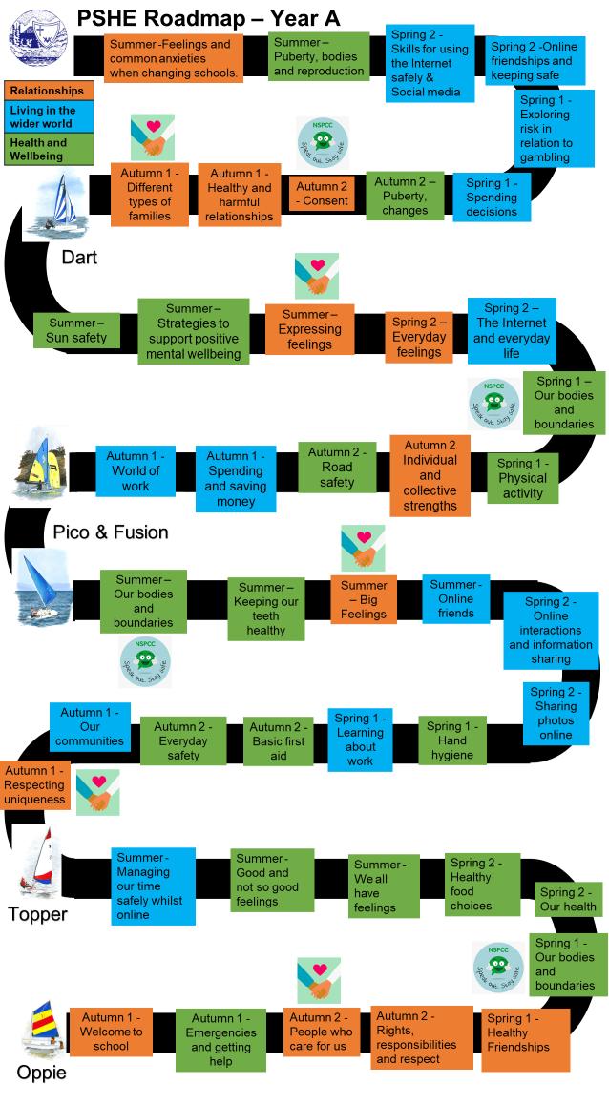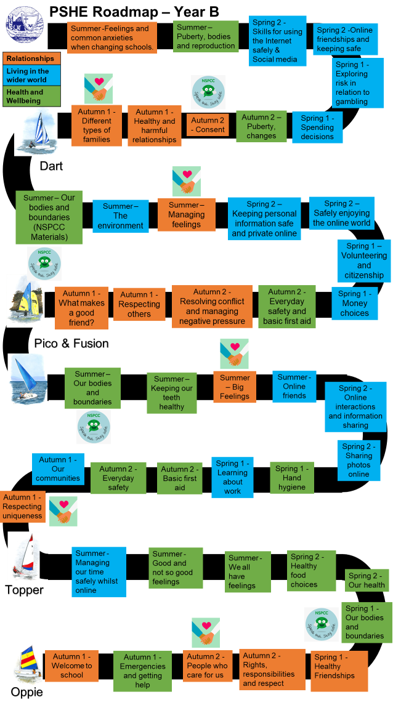
APPENDIX 2: Relationships and Health Education – Mawnan PSHE Curriculum

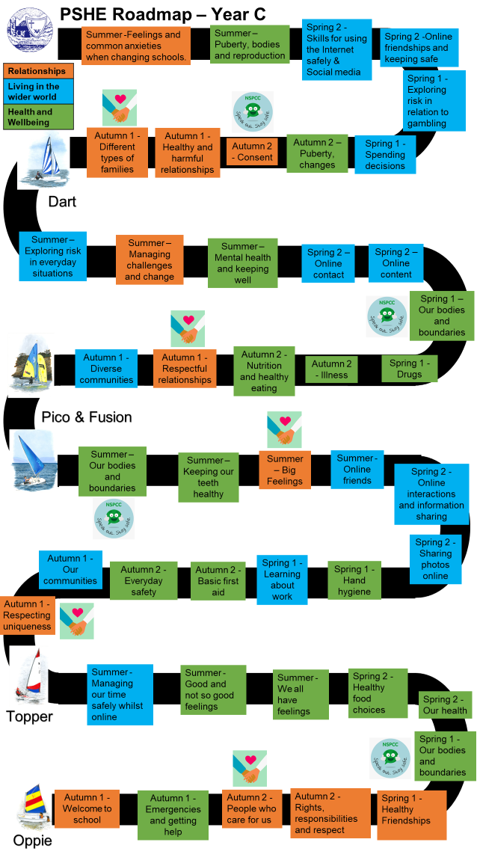
APPENDIX 3: Relationships Education vocabulary

Vocabulary
Reception | Year 1 | Year 2 | Year 3 | Year 4 | Year 5 | Year 6
Keeping safe  Boy  Girl  Routine  Clean  Washing  Family  Differences | Keeping safe  Clean  Hygiene  Boy  Girl  Penis  Vagina  Lifecycle  Family  Differences | Keeping safe  Different  Similar  Teats  Udder  Penis  Vagina  Testicles  Nipples | Keeping safe  Differences  Vagina  Womb  Penis  Testicles  Touch  Personal space  Family | Keeping safe  Differences  Personal space  Family  Lifecycle  Body change  Puberty  Penis  Vagina  Testicles  Nipple  Hygiene  Pubic hair  Breasts | Keeping safe  Puberty  Physical changes  Emotional changes  Penis  Vagina  Period/ menstruation  Nipples  Breasts  Pubic hair  Testicles  Egg  Fallopian tube  Hygiene  Womb | Keeping safe  Reproduction  Puberty  Uterus  Penis  Vagina  Nipples  Breasts  Cervix  Testicles  Relationship  Positive and negative relationship  Friendship  Touching - sexual touching  Sexual intercourse  Sperm  Egg  Fertilized  Personal information  Communication  Menstruation  Wet dream  Pubic hair  Erection  Pregnancy

APPENDIX 4: Sample letters for parents

Dear Parents and Carers,

You will be aware that as part of your child’s educational journey at Mawnan School, we aim to promote personal wellbeing and development through a comprehensive taught programme of Personal, Social, Health and Economic (PSHE) education. This curriculum gives our children the knowledge, understanding, attitudes and practical skills to live healthy, safe, productive and fulfilled lives, both now and in the future.

I am writing to let you know that over this term (Spring 1), your child’s class will be taking part in lessons which will focus on relationships and sex education (RSE), commencing on _____.
These lessons will be revisited and developed further in the final Summer term.

Lessons will include pupils learning about: Healthy relationships - including friendships; families; growing and changing – including puberty; personal hygiene; changing feelings; becoming more independent; keeping safe; developing self-esteem and confidence.

This is part of our school’s PSHE education programme, which is taught throughout the school in every year group. All teaching of PSHE will take place in a safe learning environment and it is underpinned by our school ethos and values. A variety of opportunities will be provided for pupils to ask questions, both privately and respectfully, in order to prepare them for relationships of all kinds in the modern world.

Each week, I will upload (to class dojo) a copy of the lesson that is due to be delivered as well as any resources that are being used in lessons, or that may be helpful to support your child to discuss these topics at home including videos from: https://amaze.org/ .

If you would like to know more about our PSHE curriculum at Mawnan School, including Sex Education, please find our Relationships and Health Education Policy on our school website.

For further information about RSE and health education please visit: https://www.gov.uk/government/publications/relationships-education-relationships-and-sexeducation-rse-and-health-education

As a school community, we are committed to working in partnership with parents; recent parental feedback has indicated that the overwhelming majority of parents continue to be highly supportive of the relationships and sex education programme. If you would like to find out more or discuss any concerns please feel free to get in touch.

Yours Sincerely
____________________

