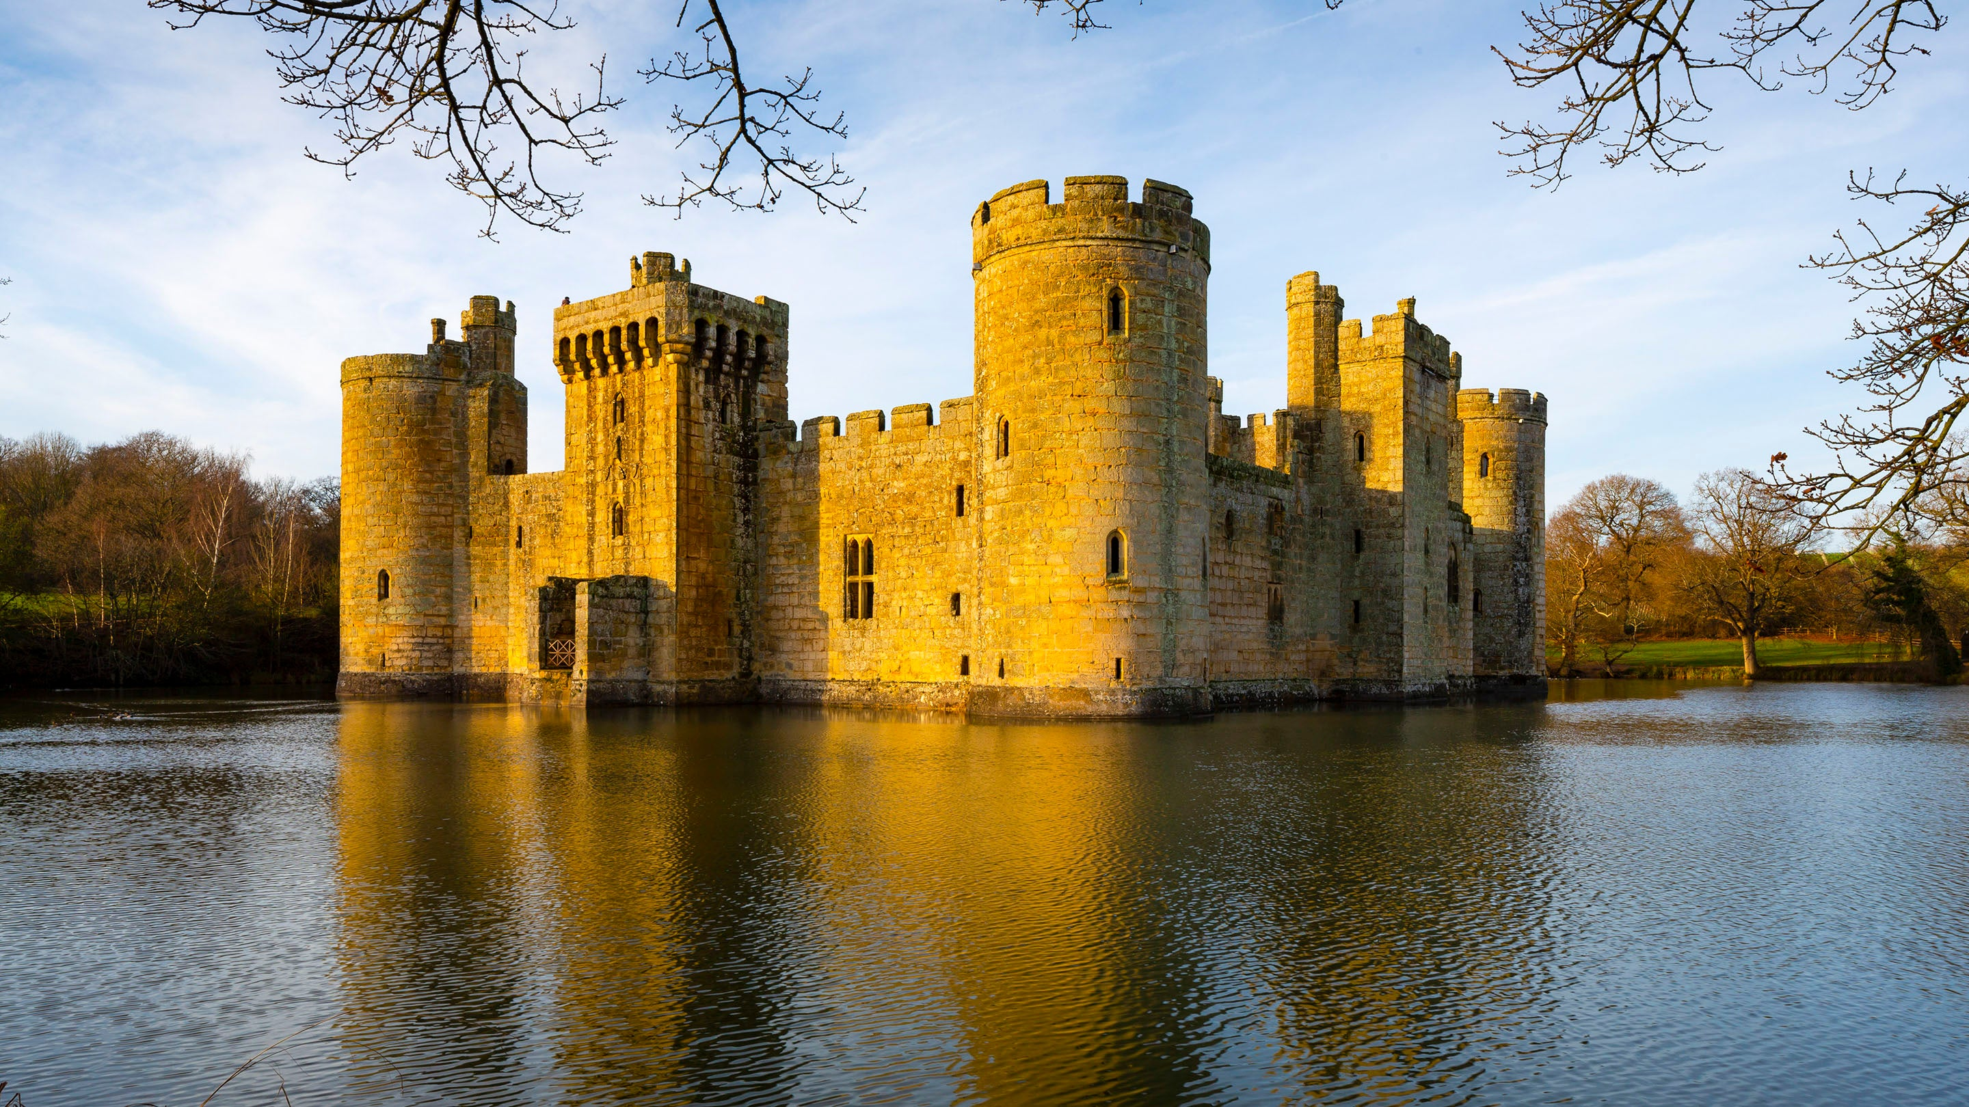

**P.E.- Complete P.E.**

Tuesday and Thursday

Jumping

Team building

**English**

**Focus texts**

Non-chronological report on castles.

How to catch a dragon.

**Grammar**

-plurals (s and es)

REVISIT IN TEXT:

- conjunctions (so but and)

- proper nouns (capital letter formation)

**Geography**

**Key questions-**

What is the difference between a city, town and a village.

What are the characteristics of England?

What are the characteristics of Scotland?

What are the characteristics of Wales?

What are the characteristics of Northern Ireland?

What are the four countries and capital cities in the UK?

**Old to New**

Term 4 Cycle C

**Science**

**Materials**

What are materials used for?

What are materials used for?

What happens when we squash, bend, twist or stretch a material?

What is it make from?

```What’s the most absorbent material?

What is waterproofing?

PSHE

Healthy friendships.

**R.E.**

Who is Jewish and how do they live?

**Art**

Be an architect.

**Maths**

**Year 1**

**Mastering number**

**White Rose Maths**

**Year 2**

**White Rose Maths**

* Multiplication and Division
* Length and height
* Mass, capacity and temperature

**Computing**

Internet safety